Nexora courses and training
Document 13 of the Nexora learning guides
Source snapshot 13 October 2026 at 17:12 UTC
Understand course applications, training approval and attendance through the shared events module.

Recognise the screen and its scope
Open /events/courses, /events/courses/[id]. CRM routes use port 3017; member routes use 3018; public website routes can use 3019. Brackets name a route parameter, not text to paste into a browser. Choose a real record or site id from the application.
This guide covers Course offerings; Training applications; Approval rejection and cancellation; Course sessions; Attendance and transfers.
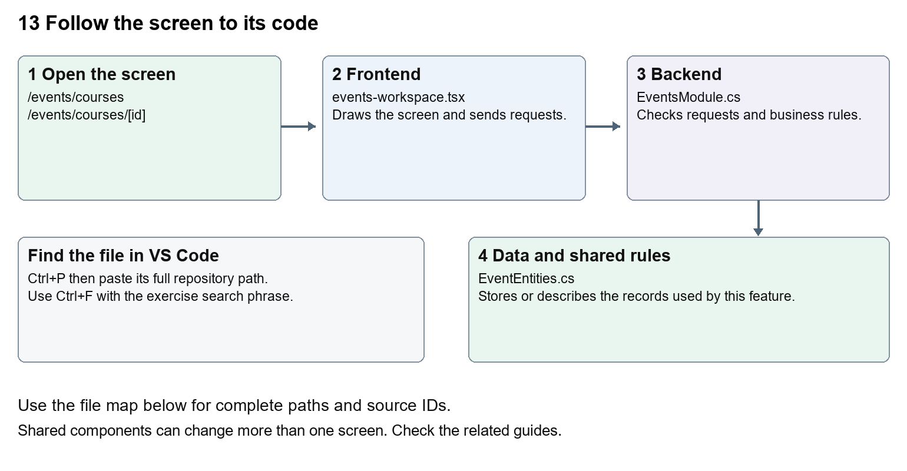
The diagram shows the file roles. The full paths below are what you paste into Ctrl+P.

Find the files in VS Code
Role | File and source ID | What it does
Screen | S0097 events-workspace.tsx | Main UI or route for this topic
Server | S0328 EventsModule.cs | Endpoints or server rules
Data | S0327 EventEntities.cs | Data shape or persistence structure

Screen S0097
apps/web/src/features/events/events-workspace.tsx
Server S0328
backend/src/Modules/Nexora.Modules.Events/EventsModule.cs
Data S0327
backend/src/Modules/Nexora.Modules.Events/Domain/EventEntities.cs
The complete HTML manual opens these source IDs inside its Source library. The Word manual shows short labelled extracts so you can learn the flow before reading large files. Each individual Markdown guide includes its complete primary files after the walkthrough.

Follow the request and the records
1. The courses route passes course as the offering kind.
2. The shared workspace loads course offerings.
3. A Contact applies for training through the enrollment endpoint.
4. Course applications can be approved or rejected by authorised staff.
5. Attendance and history are recorded against the enrollment.

Read the code with an explanation
The course route is a small wrapper. Most of the screen lives in EventsWorkspace and most rules live in EventsModule. Course-specific text and transitions are selected by offering.kind. Before changing a shared conditional, inspect how event and exam branches use it so a training improvement does not alter another offering type.
Source reference S0097 apps/web/src/features/events/events-workspace.tsx
Selected opening lines with their original numbers. The complete file is in the HTML source library.
0001 "use client";
0002 import { RecordListing } from "../shared/record-listing";
0003 import listingStyles from "../crm/record-listing.module.css";
0004 import { WorkspaceHeading } from "@/components/ui/workspace-heading";
0005 import { useRouter } from "next/navigation";
0006 import type { Route } from "next";

The import lines lead to shared components and helpers. Start at the exported component or route function; follow the request helper to the server rather than assuming the whole feature lives in this file.
Source reference S0328 backend/src/Modules/Nexora.Modules.Events/EventsModule.cs
Extract from source line 27. A fragment from a long line is shown without the rest of that line.
0027 api.MapGet("/contacts",(string? search,ICrmDirectory crm,CancellationToken ct)=>crm.SearchContactsAsync(search,ct));

On the server, look for MapGet to load records, MapPost to create or perform an action, MapPut or MapPatch to change data, and RequireAuthorization for permissions. Some shared methods register endpoints indirectly. Find SaveChangesAsync to see the database write. A request method alone does not tell you every side effect.
Source reference S0327 backend/src/Modules/Nexora.Modules.Events/Domain/EventEntities.cs
Selected opening lines with their original numbers. The complete file is in the HTML source library.
0001 using Nexora.BuildingBlocks.Domain;
0002 namespace Nexora.Modules.Events.Domain;
0003 public sealed class Offering : TenantEntity
0004 {
0005 public string Kind { get; set; } = "event";
0006 public string Name { get; set; } = "";

Follow model fields to their request names and database mapping. An id points to a particular record. A tenant id limits the organisation. A version or concurrency stamp protects newer edits. Some model files describe contracts rather than tables; check the owning DbContext before assuming storage.

Make or trace your first change
1. Press Ctrl+P and open apps/web/src/features/events/events-workspace.tsx.
2. Press Ctrl+F and search for Apply for training. In this snapshot it appears at line 30.
3. Replace this course-specific button wording. Open a course detail and verify the event branch still says Book place. Leave the request endpoint and enrollment fields unchanged.
4. Replace only Apply for training with Submit training application in that intended location. Keep quotes, tags, JSON keys and routes intact.
5. Save with Ctrl+S. Inspect Problems and the local screen. Review the diff and restore the original text when you finish practising.
Extract from source line 30. A fragment from a long line is shown without the rest of that line.
0030 >{detail.offering.kind==="course"?"Apply for training":"Book place"}</button></form></>}

These exercises have not been applied to the application. Their search phrases are verified against the captured source. Line numbers can move; the phrase and file path are your main navigation aids.

Check a change and diagnose problems
Confirm the original screen still loads, the changed words appear in the intended place, and another screen using the same component still behaves correctly. If an action fails, inspect the browser Network response, the relevant helper and server validation message. Use the common error table at the beginning of the manual. Reload on a version conflict instead of removing the version check.
A syntax error after a text edit usually means a quote, brace or closing tag changed. Compare your diff with the original. An unchanged browser result can mean the wrong port, a saved published configuration overriding a default, or a running API that has not reloaded.

Understand the current limits
The source provides training applications and attendance. A separate learning-content player, third-party learning system or certification delivery must not be inferred from a course record.

Continue learning
Related guides 12 Nexora events and bookings, 14 Nexora examinations and results.

